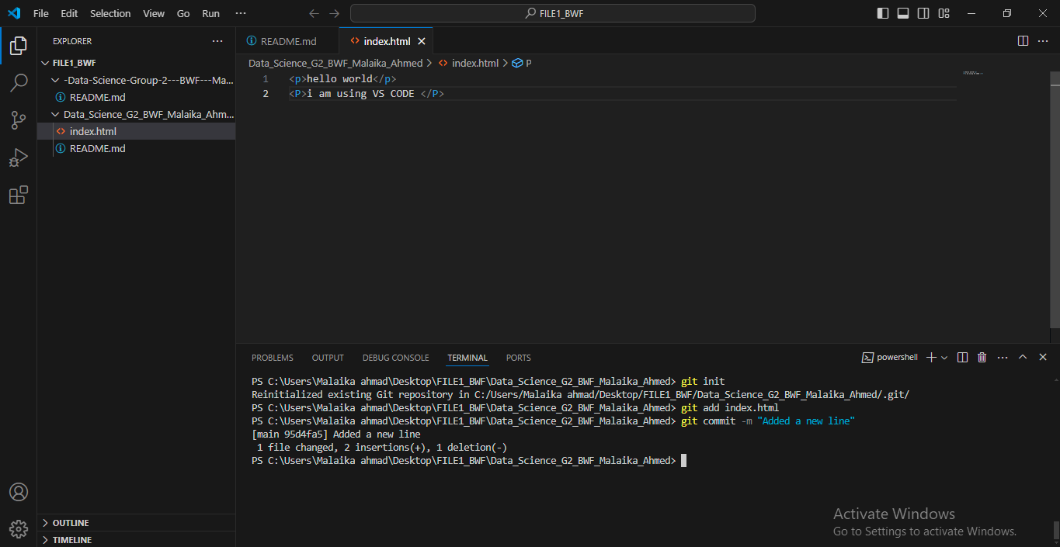

***DATA SCIENCE FELLOWSHIP-BYTEWISE LIMITED***

**TASK#01**

**Submitted by : Malaika Ahmed**